Tim Jayson
CS-340 Project 2 screen shots

Water Rescue:
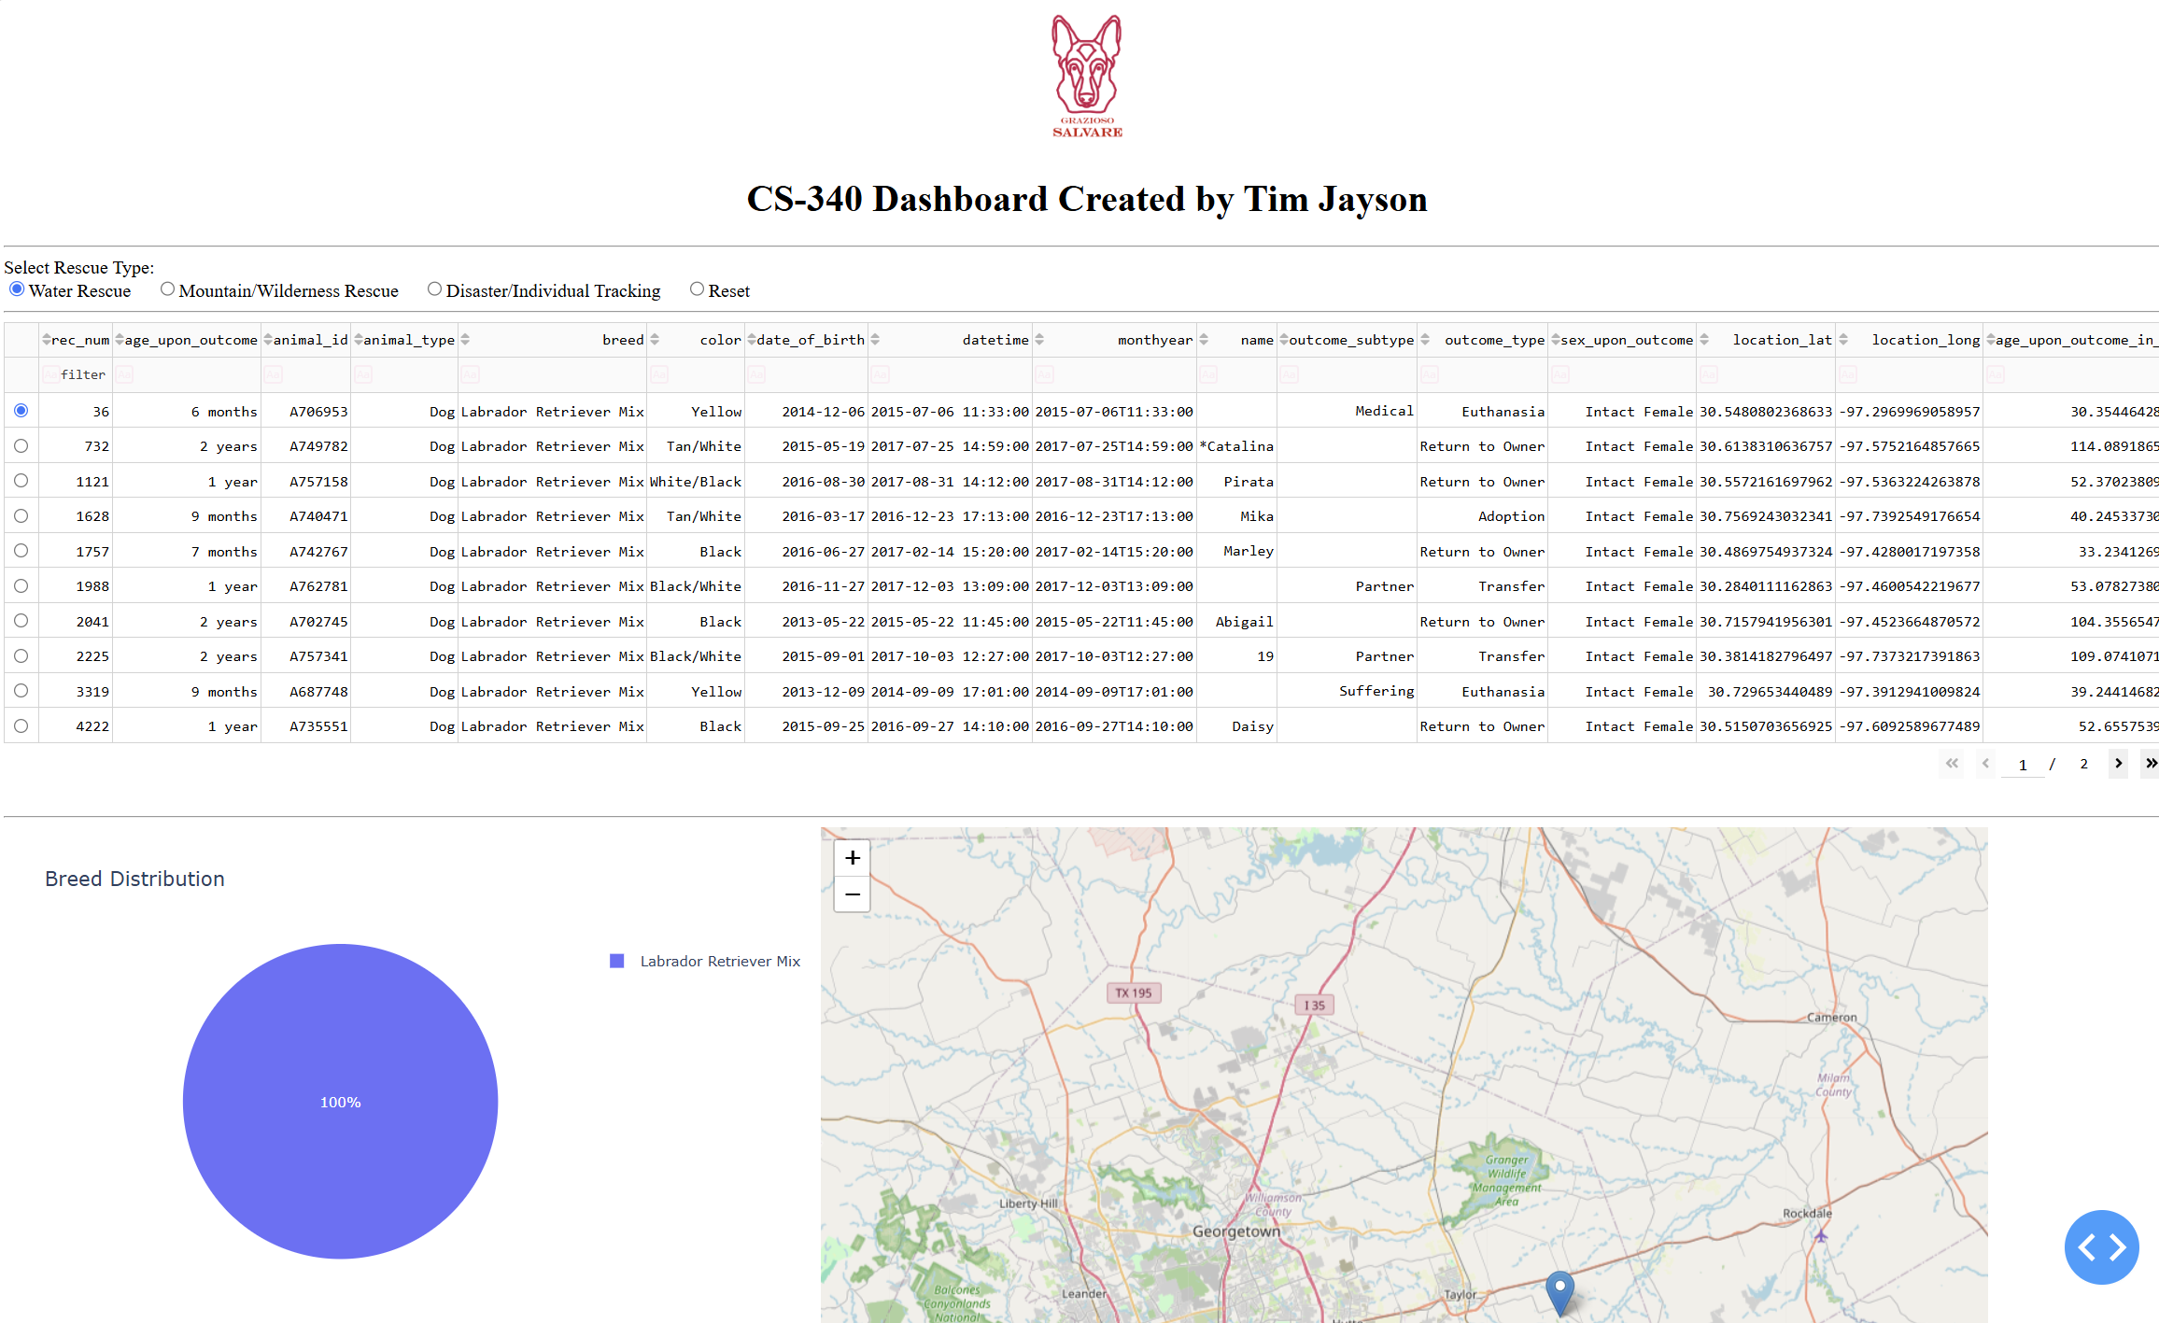
Mountain/Wilderness Rescue:
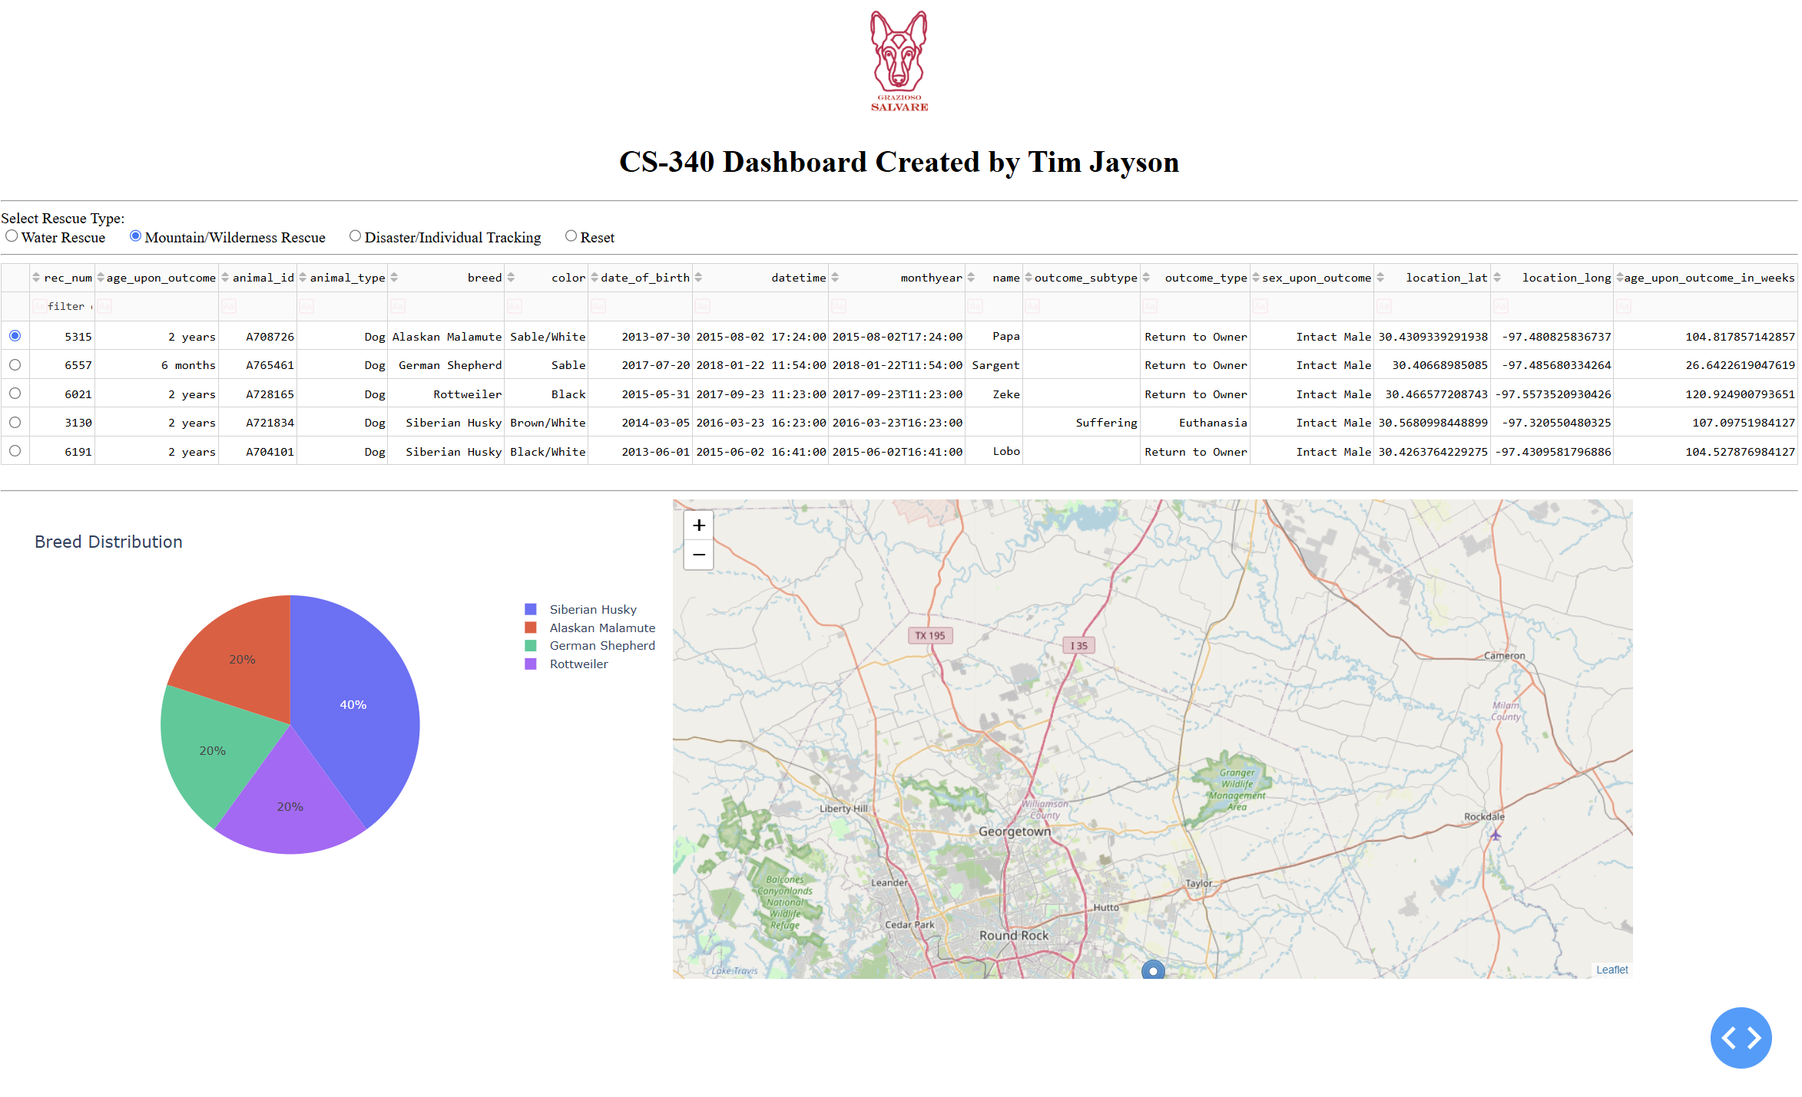

Disaster/Individual Tracking
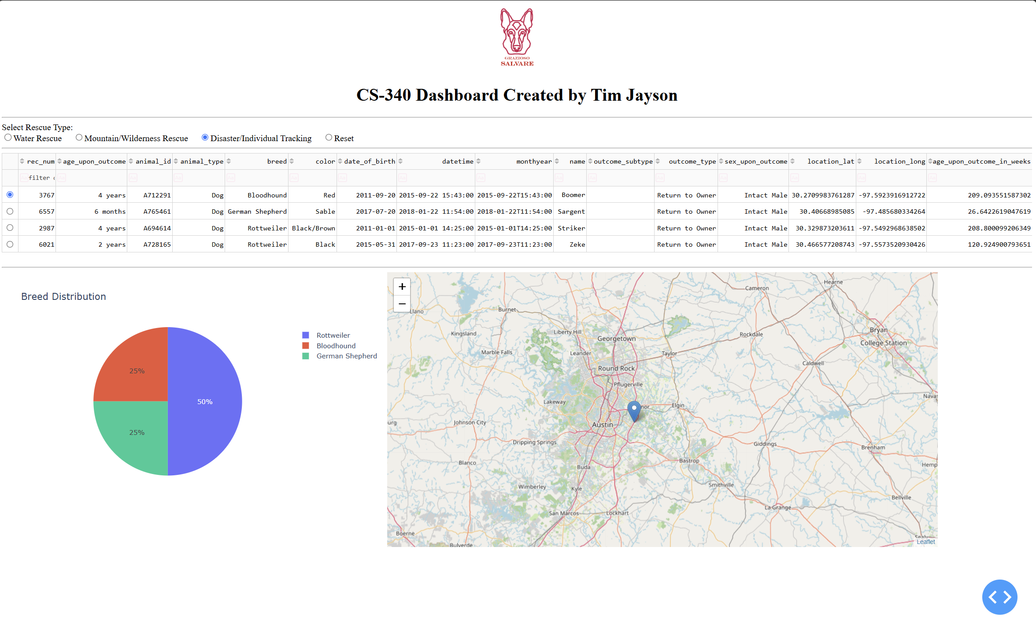
Reset